# C2- S4-PRACTICE

*NOTE: check your* ***THEORY slides*** *to answer those questions!*

# EXERCISE 1 – BOOK & AUTHORS

We want to manage books and authors:

* A book has always 1 author only
* An author could write many books.

|  |
| --- |
| **Author** |
| authorID |
| name |
| dateOfBirth |
| country |

|  |
| --- |
| **Book** |
| bookID |
| Title |
| publishYear |
| language |

**Q1** – What is the relation between Book and Author tables? Why?

Relation between Book and Author tables is many to one because author can write many books but only book have write by only one author.

* + Complete the missing attributes or table to allow this relation

One many

|  |
| --- |
| **Author** |
| authorID |
| name |
| dateOfBirth |
| country |

|  |
| --- |
| **Book** |
| bookID |
| Title |
| publishYear |
| language |
| authorID |

**Q2** – For each table, complete the following arrays, by specifying for each attribute:

* + The field type (SQL type) and size
  + Can be null or not?
  + Is a primary key or foreign keys?

**AUTHOR TABLE**

|  |  |  |  |
| --- | --- | --- | --- |
| Attribute name | Type / size | Can be Null? | Key |
| authorID | Int | No, it can’t | Primary key |
| name | varchar(15) | No, it can’t |  |
| dateOfBirth | Date | Yes, it can |  |
| country | Varchar(25) | Yes, it can |  |

**BOOK TABLE**

|  |  |  |  |
| --- | --- | --- | --- |
| Attribute name | Type / size | Can be Null? | Key |
| bookID | Int | No, it can’t | Primary key |
| Title | Varchar(100) | No, it can’t |  |
| publishYear | date | No, it can’t |  |
| language | Varchar(100) | No, it can’t |  |
| authorID | int | No, it can’t | Foreign key |

**Q3** – Write the SQL statement to create the 2 tables with appropriate properties

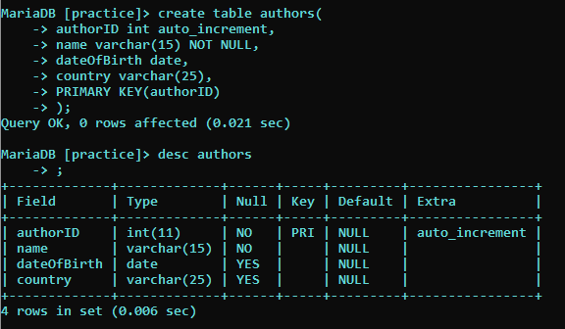

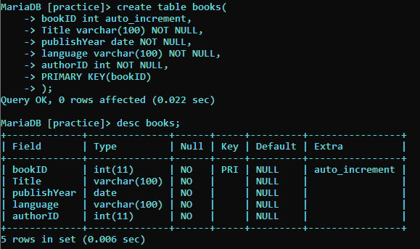

**Q4–** Write the statement to insert 5 books and 5 authors

* + Find the book and author information on the Internet

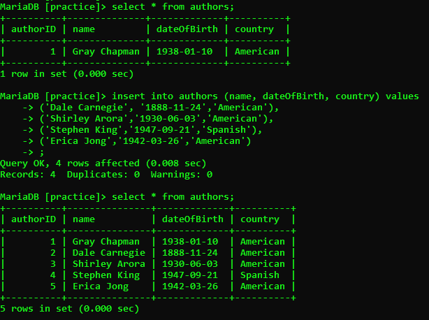

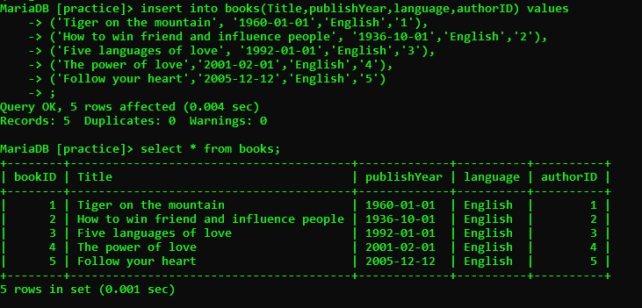

**Q5–** Write the SQL statement to **delete 3 of your books** from the database

# 

# EXERCISE 2 – USERS & POSTS

We want to manage **users** and **posts** (like posts on Facebook)

* A post is related to **1 user only**
  + A post has a body (the text of the post)
* User can have **many posts**
  + A user has a first name, and a nick name (optional)

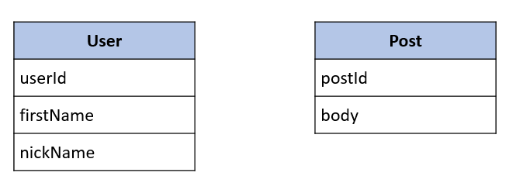

**Q1** – What is the relation between User and Post Table?

Relation between User and Post Table is one to many because User can have many posts and one post is related by one user only.

* + Complete the missing attributes or table to allow this relation

One Many

|  |
| --- |
| User |
| userId |
| firstName |
| nickName |

|  |
| --- |
| Post |
| postId |
| Body |
| userId |

**Q2** – For each table, complete the following arrays, by specifying for each attribute:

* + The attribute type (SQL type) and size
  + Can be null or not?
  + Is a primary key or foreign keys?

**USER TABLE**

|  |  |  |  |
| --- | --- | --- | --- |
| Attribute name | Type / size | Null? | Key |
| userId | int | Null | Primary key |
| firstName | Varchar(100) | Null |  |
| nickName | Varchar(100) | Not null |  |

**POST TABLE**

|  |  |  |  |
| --- | --- | --- | --- |
| Attribute name | Type / size | Null? | Key |
| postId | int | Null | Primary key |
| Body | Varchar(255) | Not null |  |
| userId | int | Null |  |

**Q3** – Write the SQL statement to create the 2 tables with appropriate properties

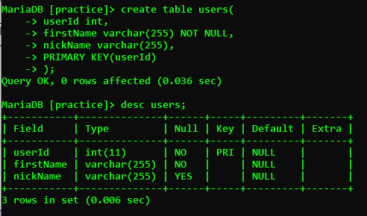

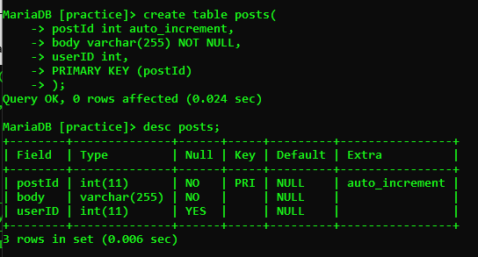

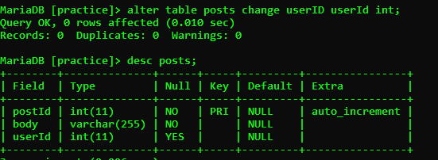

**Q4–** Write the statement to insert the following users and posts

Notes:

* ---- means: no value (the nickname is optional!)
* We don’t specify the KEY, it’s your business!

**USERS**

|  |  |
| --- | --- |
| First name | Nick name |
| Ronan | roro |
| Sokea | ---- |
| Edouard | doudou |

**POSTS**

|  |  |
| --- | --- |
| Post body | From |
| Hello all! | Ronan |
| I like rice | Ronan |
| YES YES | Sokea |

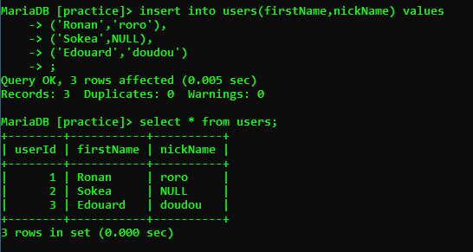

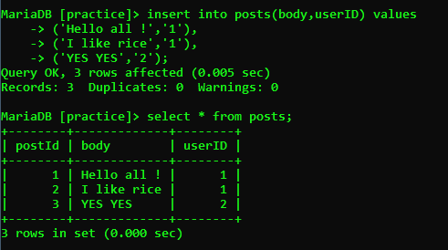

**Q5–** Write the statement to delete the user Edouard

* What’s happen? Can we delete it? Why?

It will delete record in table. Yes, we can delete it. Because we write statement ‘delete from users where userId =3;’



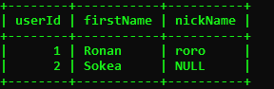

**Q6–** Write the statement to delete the user Ronan

* What’s happen? Can we delete it? Why?

It will delete record in table. Yes, we can delete it. Because we write statement ‘delete from users where userId =3;’

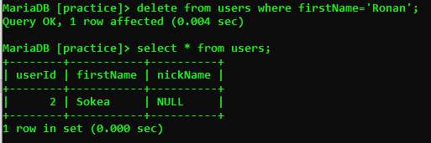

**Q7–** Write SQL statement to remove the rows related to Ronan user:

* Hello all!
* I like rice

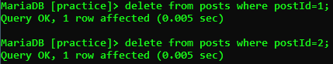



**Q8–** now try again to delete the user Ronan

* What’s happen? Can we delete it? What can you conclude?

It will error. No, we cannot delete it because the firstName of Ronan doesn’t have in table users.

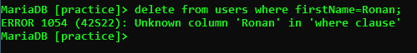

**Q9–** Add a new POST in the POST table with a userId which does not exist in the User table (ex: userID = 45) 

* What is happen? Why?
* Cannot add post because column count does not match value.